**Computer Logic Design BDS-2A - spring 2021**

**Assignment – 2(a)**

**Question 1:** **Ideal Toy Company has to develop a new toy “Magic-Bulb”. Magic-Bulb is a box having 8 buttons and 8 bulbs on it. Buttons are associated with numbers 0 to 7 (i.e. 1 number written on 1 button). For any number pressed by user Magic-Bulb turns a specific bulb on. Bulbs “Green”, “Yellow”, “Pink”, “Orange”, “Red”, “Purple”, ”Blue” and ”White” are associated with numbers 0, 1, 2, 3, 4, 5, 6 and 7 respectively. Your task is to design Logic diagram for Magic-Bulb’s circuit using the concepts studied so far.**

1. **Make truth table for Magic-Bulb**

|  |  |  |  |  |  |
| --- | --- | --- | --- | --- | --- |
| **Bulbs** | **A** | **B** | **C** | **Max-terms** | **Min-terms** |
| **0 (Green)** | 0 | 0 | 0 | **(A+B+C)’** | **A’B’C’** |
| **1 (Yellow)** | 0 | 0 | 1 | **(A+B+C’)’** | **A’B’C** |
| **2 (Pink)** | 0 | 1 | 0 | **(A+B’+C)’** | **A’BC’** |
| **3 (Orange)** | 0 | 1 | 1 | **(A+B’+C’)’** | **A’BC** |
| **4 (Red)** | 1 | 0 | 0 | **(A’+B+C)’** | **AB’C’** |
| **5 (Purple)** | 1 | 0 | 1 | **(A’+B+C’)’** | **AB’C** |
| **6 (Blue)** | 1 | 1 | 0 | **(A’+B’+C)’** | **ABC’** |
| **7 (White)** | 1 | 1 | 1 | **A+B+C** | **ABC** |

1. **Write functions equations using AND & NOT operations only**

F0=A’B’C’

F1=A’B’C’

F2=A’BC’

F3=A’BC

F4=AB’C’

F5=AB’C

F6=ABC’

F7=ABC

1. **Write functions equations using OR & NOT operations only**

F0=(A+B+C)’

F1=(A+B+C’)’

F2=(A+B’+C)’

F3=(A+B’+C’)’

F4=(A’+B+C)’

F5=(A’+B+C’)’

F6=(A’+B’+C)’

F7=A+B+C

1. **Draw logic circuit diagram for part b**

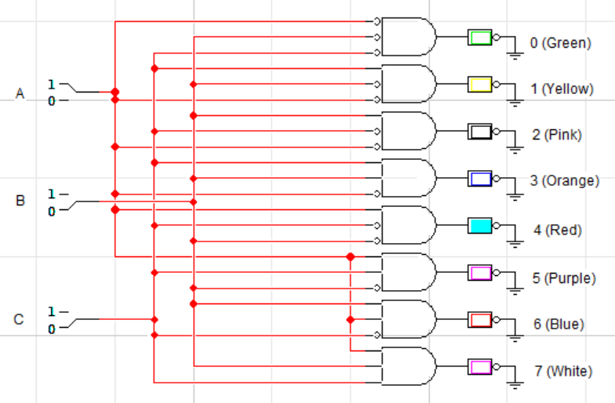

1. **Draw logic circuit diagram for part c**

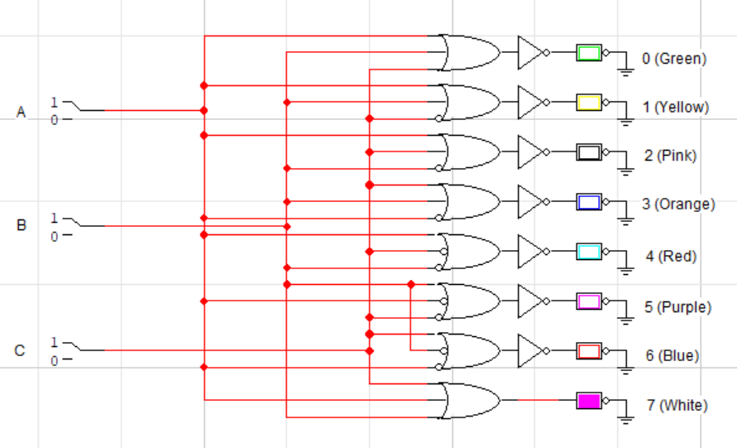

1. **Are these single-output circuits or multiple-output circuits?**

These are multiple output circuits because they take 3 inputs to create a combination for a specific color of bulb.